**Follow this only if you want you to try out my codes, otherwise, feel free to ignore this.**

1. Check you already have pip installed in your comp. To do this, press windows key > search “cmd”, enter the line: pip  
   If successful, it should load this:

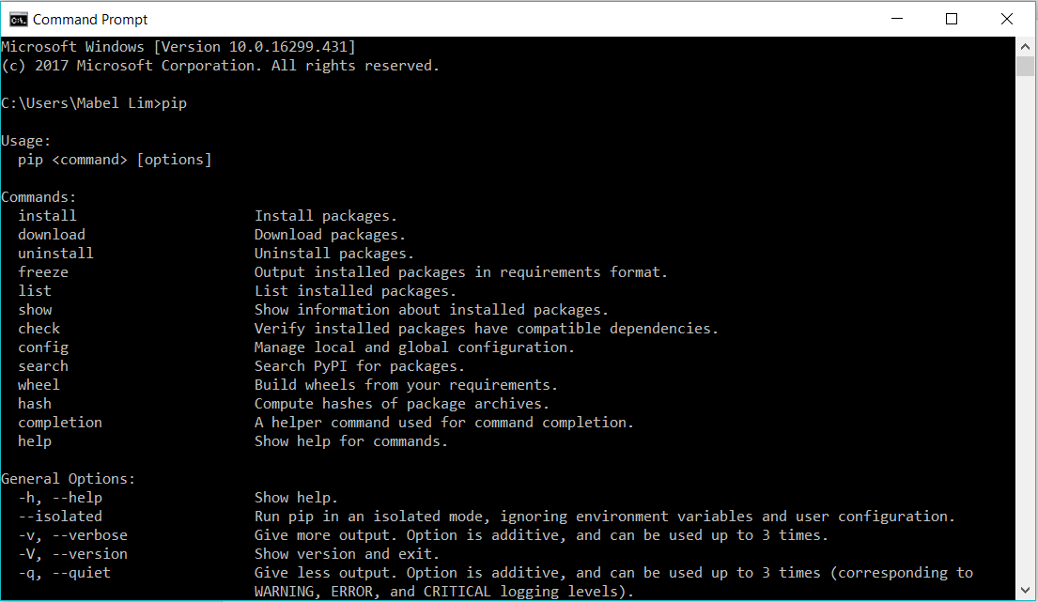

Nothing? Follow this cool dude: <https://www.youtube.com/watch?v=Jw_MuM2BOuI>

(note: in the video, the file that he uses is python35, however, we use anaconda3, so replace anything python35 to anaconda3

summary: find where your pip file is (usually under C:\Users\User\Anaconda3\Scripts, add that address into the path under System Environmental Variables)

1. Next, type in pip -V to check the version



The version should be 10.0.1 or it will not download textblob

1. To update pip: type in conda update pip  
   
2. Once everything has load, remember to accept the request by entering y
3. Now that pip is done, download textblob by entering pip install -U textblob
4. Done!

**Downloading nltk**

1. Click the windows key, type in “power shell” (or go to cmd)
2. Type in “conda install nltk”

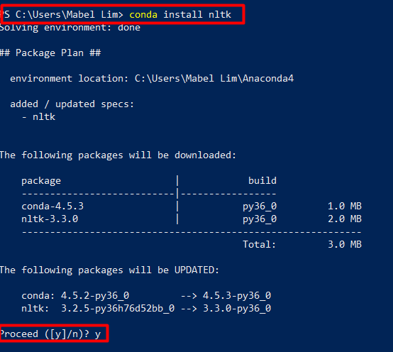

1. Then type “y” when prompted
2. Then go to cmd to check if you’re already downloaded nltk:

type in “pip install nltk”

If you’re already downloaded, this should appear

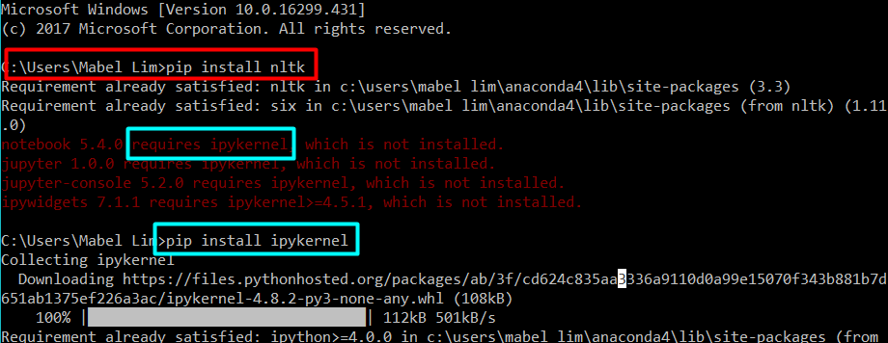

But notice the lines in red, and they are asking you to download something else. Simply type in “pip install (what you’re missing)

1. The go to jupyter, and type the following:   
   “import nltk”  
   “nltk.data.path”

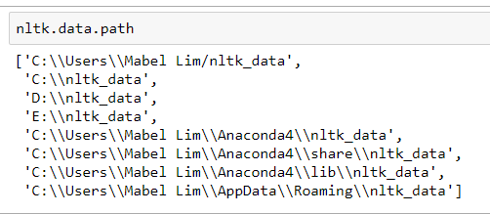

The output will give you a list of paths. Try search each directory in the file explorer one by one until one of the paths will contain a folder called “nltk_data”

1. If you can’t find the folder anywhere:
   1. Create a new folder at where you want the folder to be at
   2. Then copy the directory
   3. Go back to jupyter, type in “nltk.data.path.append(“
2. Leave that page open.
3. Next, go to this website:

<http://www.nltk.org/nltk_data/>

and search for stopwords. Click the download link.

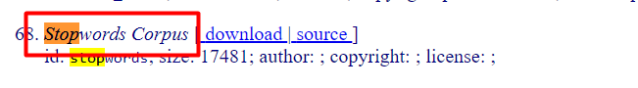

1. Unzip the file and exact the file to the path you’ve found earlier on. Open that window and copy the file directory:

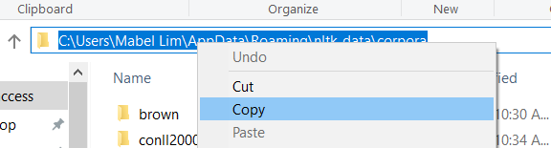

1. … and paste it in the extraction window.

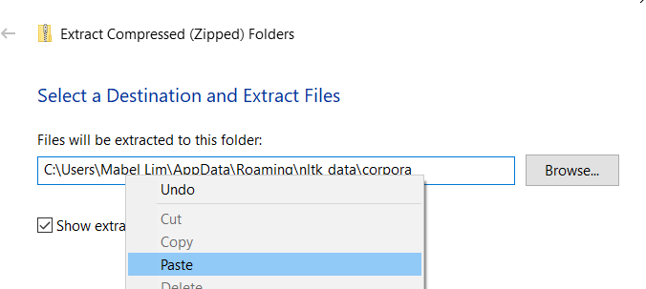

1. If this does not work, another way is to download it through jupyter: 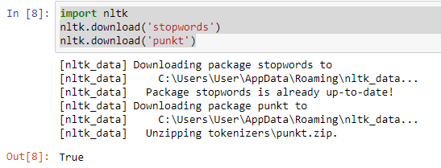
2. Done!
3. When testing out my codes, it is a good idea to run them at least twice.